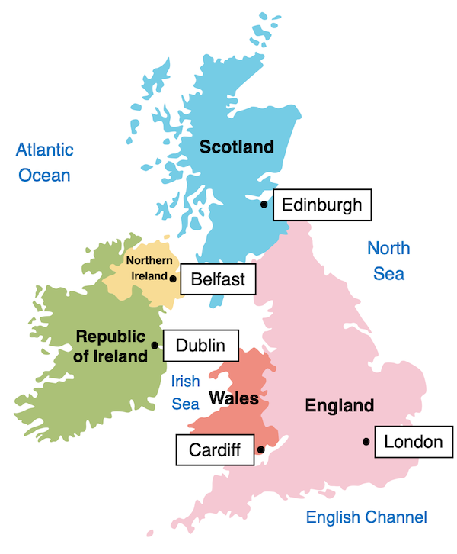
Swallow Falls
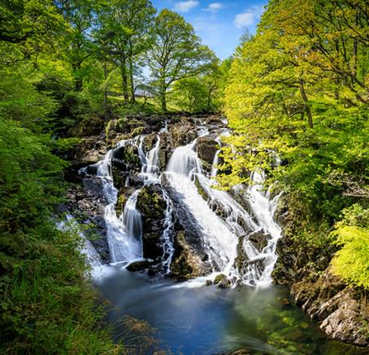
Ben Nevis
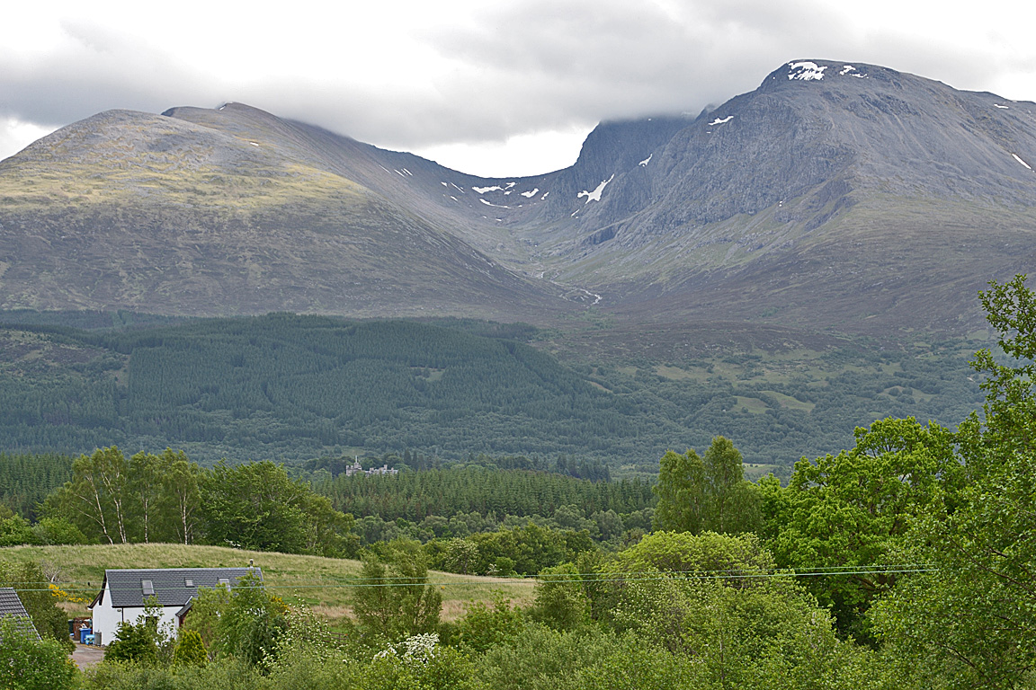
Giant’s Causeway
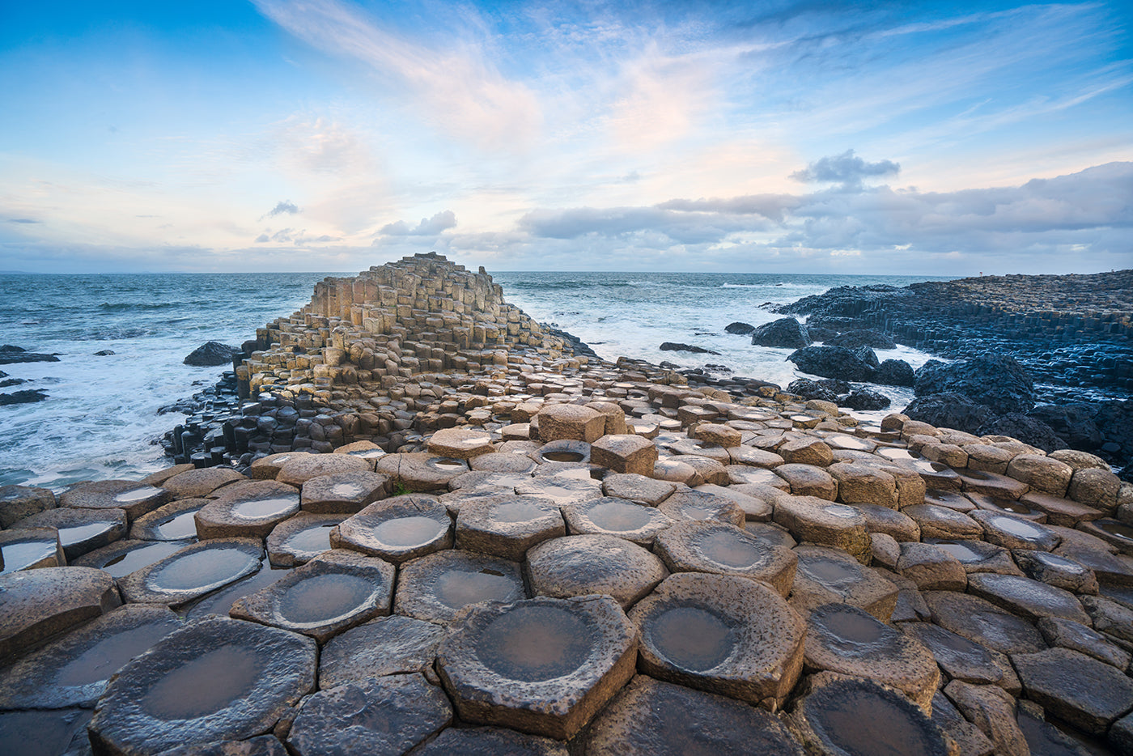
River Thames
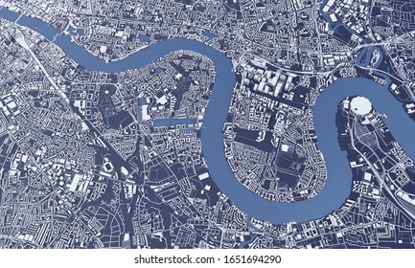
Old to New
Geography
Mawnan Smith is a village. It is located near the town of Falmouth. Our closest city is Truro.
The United Kingdom is made up of four countries: England, Scotland, Wales and Northern Ireland.
Each country has its own capital city: London, Edinburgh, Cardiff and Belfast.
Different physical features can be found in each country like the mountains of Scotland or the waterfalls in Wales.

Vocabulary:
Village
Town
City
England
Scotland
Wales
Northern Ireland
London
Edinburgh
Belfast
Cardiff
Physical feature
Human feature
Mountain
Waterfall
River Thames
Giant’s Causeway.

